JCS 100.1

Your ideas

Words and ideas of others

Your writing or presentation

**Body of your work with an in-text citation**

Stefan and Anna Kuchar arrived at Ellis Island in the winter of 1898 (Kuchar, 2000).

References

Kuchar, M. (2000). *Kuchars, kitchens, and kuchen*. New York, NY: Skyscraper Publishing.

**List of references with more detail**

JCS100.2

Your own ideas or analysis,   
including common knowledge

Words and ideas of others

Direct quotation

Paraphrasing

Summarizing

JCS100.3

As Edgar Smith (2012) explains . . .

Here are a few sentences with your own ideas.

These are the words of Edgar Smith that support your points.

JCS100.4

**In-text citation**

Stefan and Anna Kuchar arrived at Ellis Island in the winter of 1898 (Kuchar, 2000).

References

Kuchar, M. (2000). *Kuchars, kitchens, and kuchen*. New York, NY: Skyscraper Publishing.

**List of references   
at end of document**

last name of author

year of publication

page or paragraph number   
 for a direct quotation

(Baker, 2013, p. 2)

parentheses

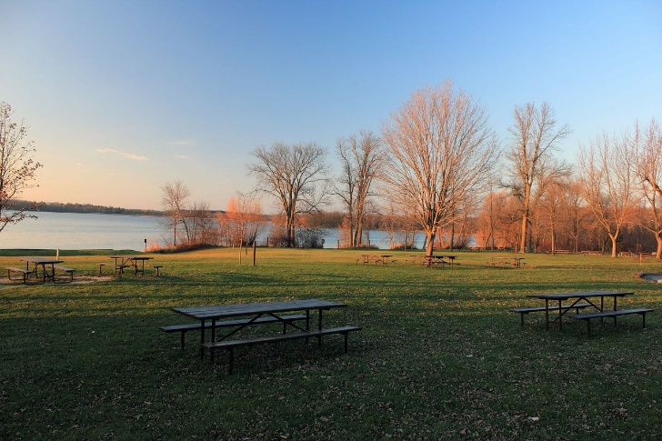

explanation

figure number

title

Figure 1. Lake Stone picnic area. Our family has been meeting here for the past 70 years (Gorski, 2016).

citation

title

description

figure number

Figure 1. Kuchar family reunion. The Kuchar family is shown at its first family reunion at Tanglewood (Gorski, 1950).

citation

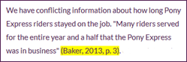



In-text citation list

Baker, 2013

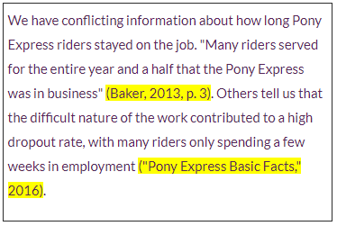



In-text citation list

Baker, 2013

Pony Express Basic Facts, 2016

title of work

publication information

author's name

year of publication

Baker, P. (2013, November). History of the Pony Express. US News, 11(1), 1-5.  Retrieved from http://www.usnews.com/opinion/articles/2013/11/04/history-of-pony-express

DOI if one is available or “Retrieved from” URL

100.5

I don’t see an author’s name…  
When was this published? Is this a journal?  
Yikes… no page numbers!  
Do I need to copy the URL?

